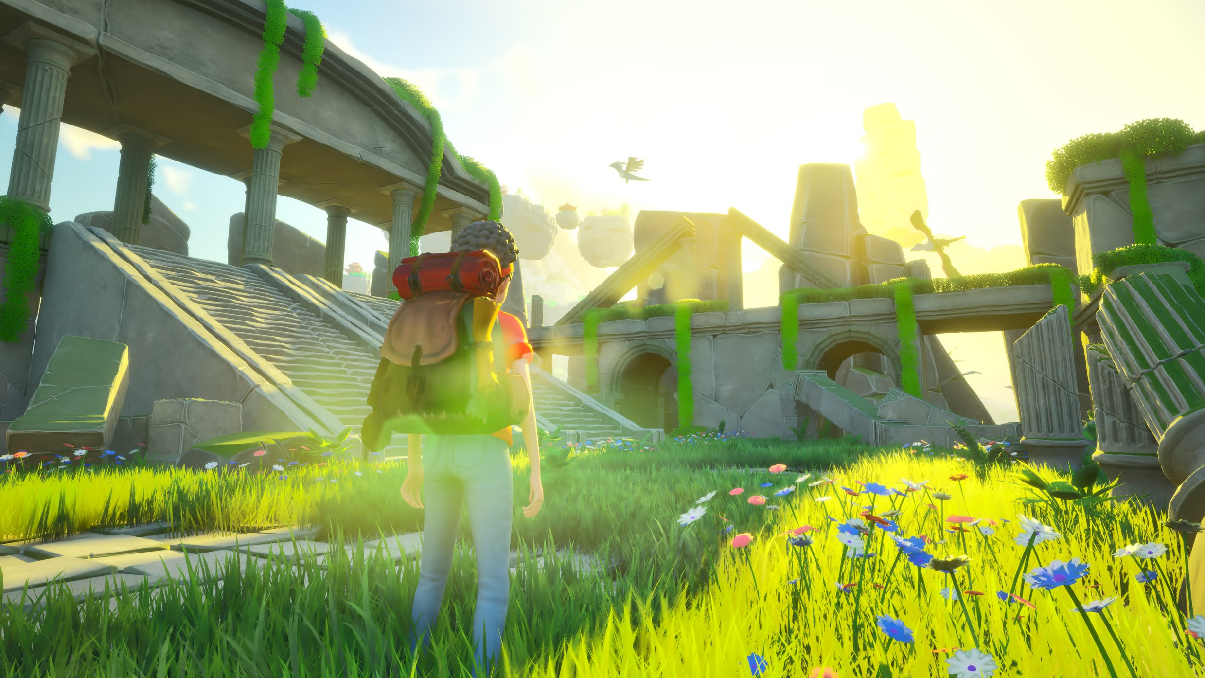

# MEET CINDERWAKE, A TRUE COMPETITOR TO PALWORLD & POKÉMON

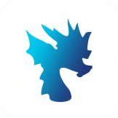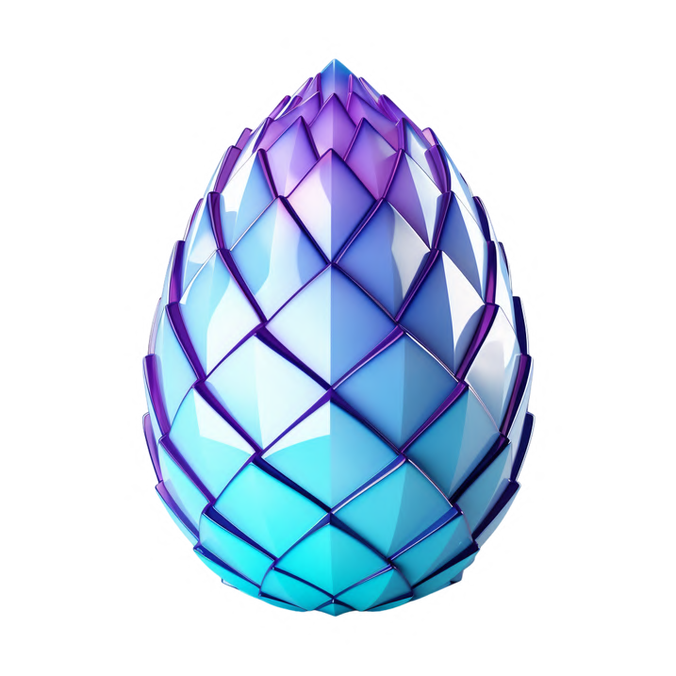

In Cinderwake, every creature you tame possesses unique abilities, offering endless strategic possibilities in battles against fierce bosses and other players. Craft your own items and weapons within the game, shaping the experience to your will, and dive into innovative combat mechanics that keep you on your toes.

With Web3 integration on the Solana blockchain, the game offers unprecedented opportunities for community engagement and immersive gaming experiences. Join the adventure and unleash your inner dragon lord in Cinderwake!

# MOBILE GAMING IS BORING

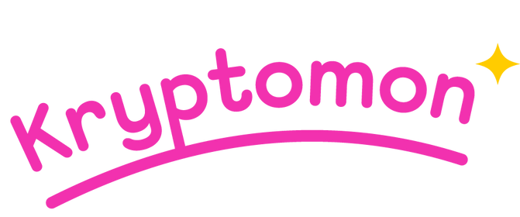

Mobile gaming often feels monotonous with repetitive turn-based combat, auto combat, and auto pathing. Despite Pokémon GO's success, the lack of Pokémon or expansive open-world games on mobile leaves players craving more engaging experiences on their devices. The lack of crossplay (PC Support) is also playing a factor.

# WE KNOW WHAT PLAYERS WANT

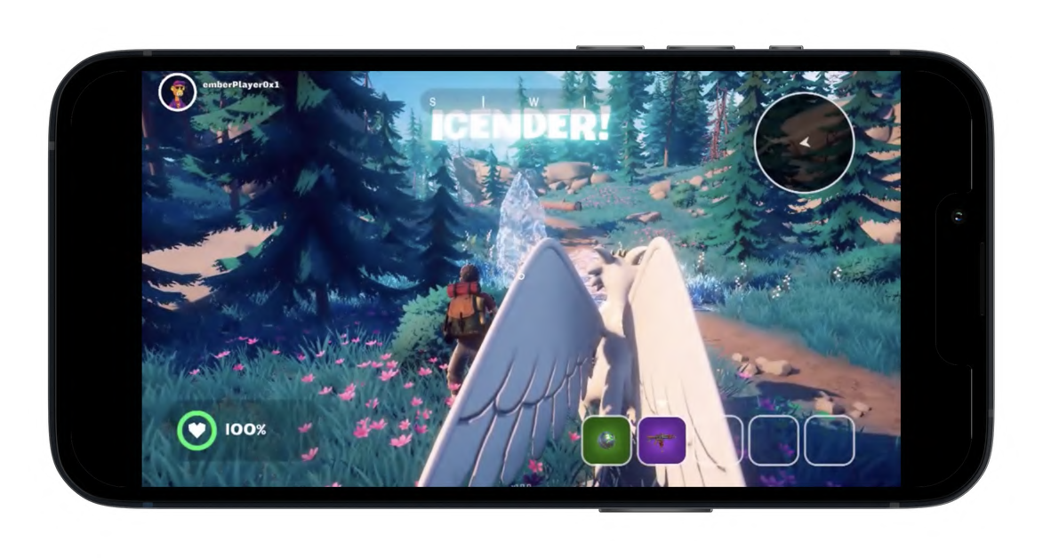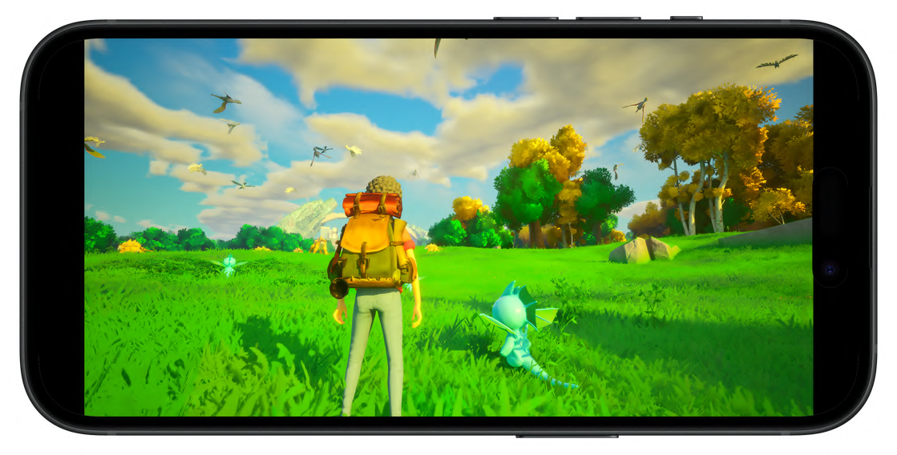With Cinderwake, we draw from our experience developing our previous projects, a turn-based Pokémon-style game. While our previous projects was fun, it lacked the uniqueness players crave. Leveraging our expertise in crafting web3 games, we understand what players desire. Cinderwake goes beyond the norm, offering a vast open world, NFT integration, and dynamic gameplay.

By listening to player feedback and building upon our knowledge of the gaming industry, we"ve created an immersive experience that meets players" desires head-on. Cinderwake isn"t just another game; it"s a testament to our commitment to delivering what players truly want.

# THE WORLD OF CINDERWAKE

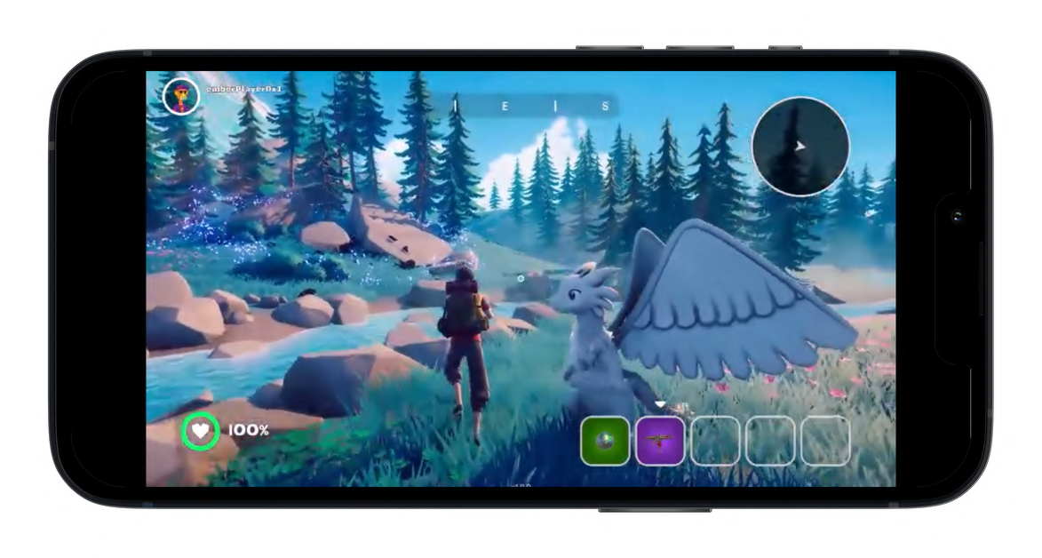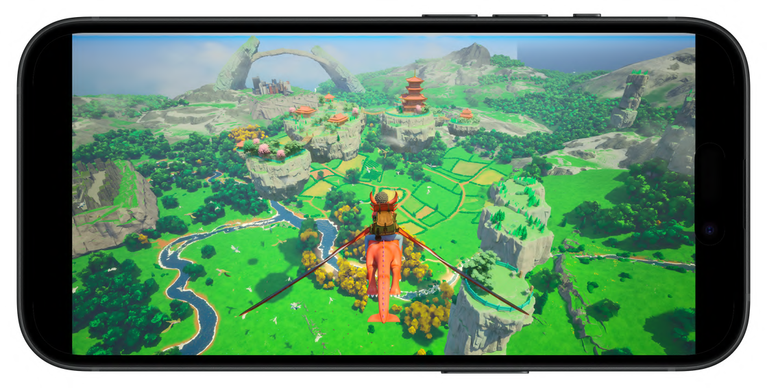Dive into the breathtaking world of Cinderwake, where the skies teem with majestic dragons of unparalleled abilities awaiting your command! Traverse vast landscapes, from lush forests to treacherous mountains, as you collect an array of unique dragons each with their own awe-inspiring powers.

Challenge formidable bosses, engage in heart-pounding battles against fellow players and creatures, and unravel hidden secrets lurking within the realm. With its groundbreaking web3 integration on the Solana blockchain, Cinderwake offers an unparalleled gaming experience that will leave you on the edge of your seat, hungry for more adventure!

# AN OPENWORLD EXPERIENCE

Cinderwake sets itself apart in mobile gaming by offering players a sprawling open world to explore, a feature seldom seen in mobile games. From lush forests to towering mountains, the game world beckons adventurers to embark on epic journeys and uncover its hidden secrets.

Cinderwake’s expansive open world not only provides hours of exploration and entertainment but also sets a new standard for mobile gaming experiences. With its vast landscapes, rich environments, and immersive gameplay, Cinderwake invites players to embark on unforgettable adventures right at their fingertips. Prepare to lose yourself in a world unlike any other, where the possibilities are as limitless as your imagination.

# A UNIQUE BREEDING SYSTEM

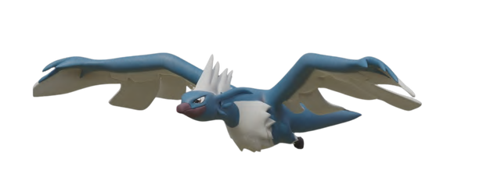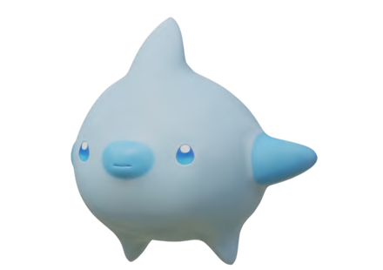In Cinderwake, the allure of creatures lies in their rarity, each one as unique as a gemstone. The game meticulously tailors every hatched creature, ensuring a truly personalized experience. From common to legendary, creatures come in various rarities, each boasting distinct traits and abilities.

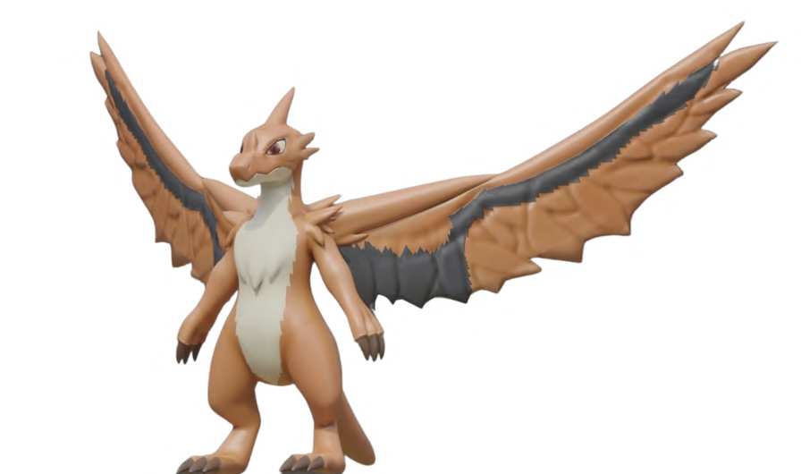

This rarity system not only fuels excitement but also fosters player retention. Unlike other creature-collecting games, Cinderwake"s competitive edge shines with the concept of limited breeding opportunities, enhancing scarcity and rarity. Certain creatures can only breed once, adding a layer of strategy and increasing their coveted status among players.

# DIFFERENT ELEMENTS



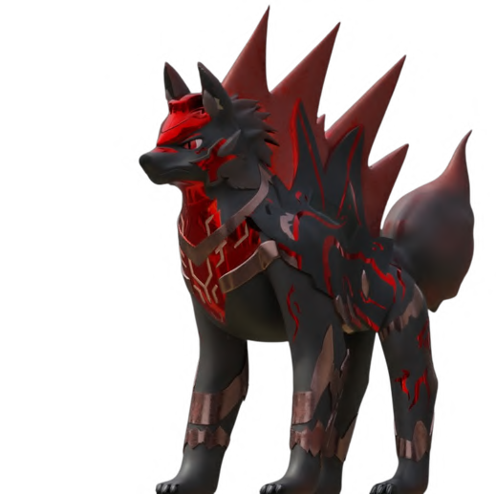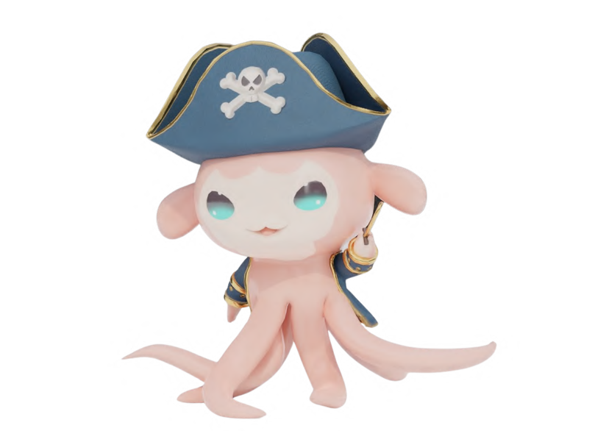In Cinderwake, dragons and creatures are imbued with elemental diversity, ranging from traditional elements like fire, water, and wind to more exotic and undiscovered elements waiting to be unveiled. Each creature possesses its own unique elemental composition, influencing their abilities, strengths, and weaknesses.

From scorching flames to tranquil waters, these elements shape the world of Cinderwake and add depth to gameplay. Players will encounter a wide variety of creatures, each harnessing the power of their elemental essence, as they embark on epic adventures and unravel the mysteries of this enchanting realm.

# DIFFERENT CREATURES

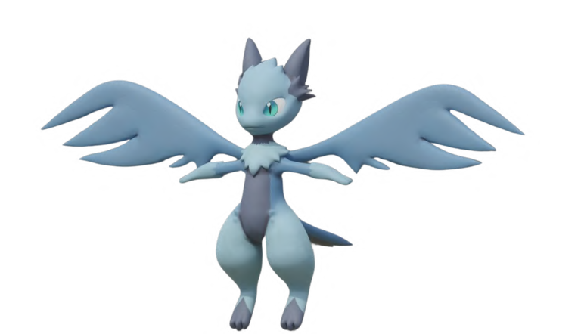

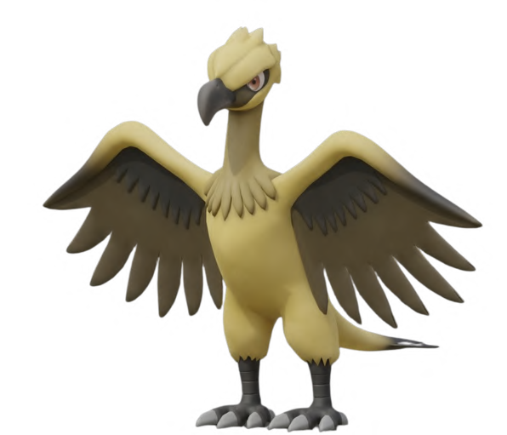In Cinderwake, an enchanting variety of creatures stand ready to aid players, each offering unique abilities and perks. From loyal combat companions to majestic mounts and even suppliers of valuable crafting materials, these creatures enrich every aspect of the game.

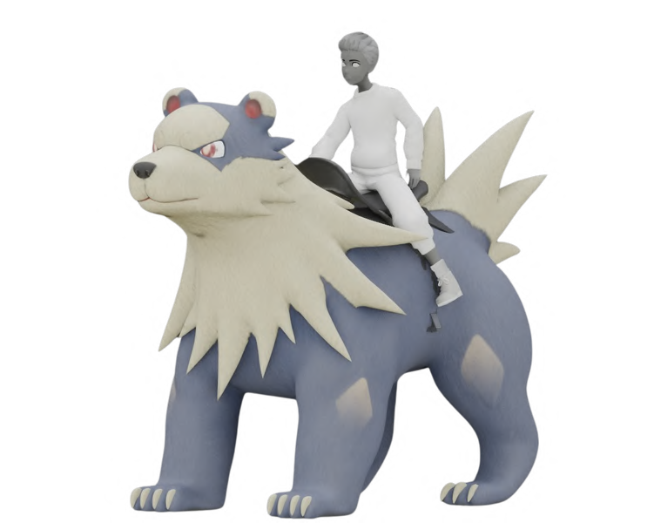

However, among them, legendary rarities emerge on special occasions, boasting unparalleled power and prestige. These legendary beings, appearing sporadically and vanishing for extended periods, up to months, add an extra layer of excitement and challenge to the adventure, rewarding those who encounter them with truly exceptional experiences.

# WEAPON DIVERSITY IN CINDERWAKE

In Cinderwake, players have access to a diverse array of weapons, each tailored to suit different playstyles and combat scenarios.

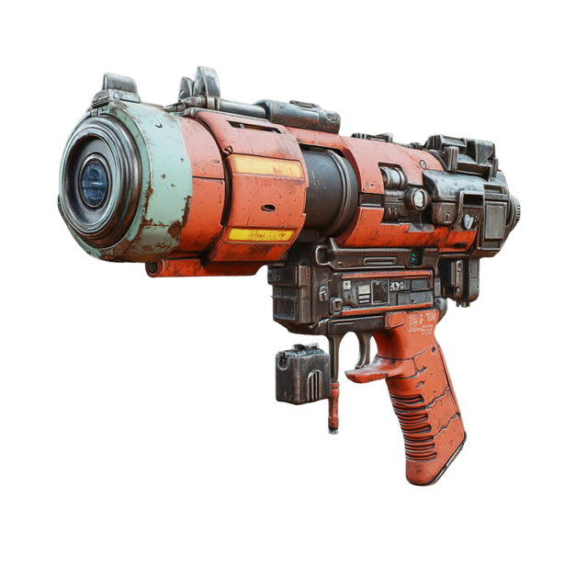From firearms and swords to bows and magical staves, the game offers a wide variety of options for players to wield. Each weapon in Cinderwake has its own unique utility and strengths. Some weapons may excel in close-quarter combat, while others may be better suited for ranged attacks or magical abilities.

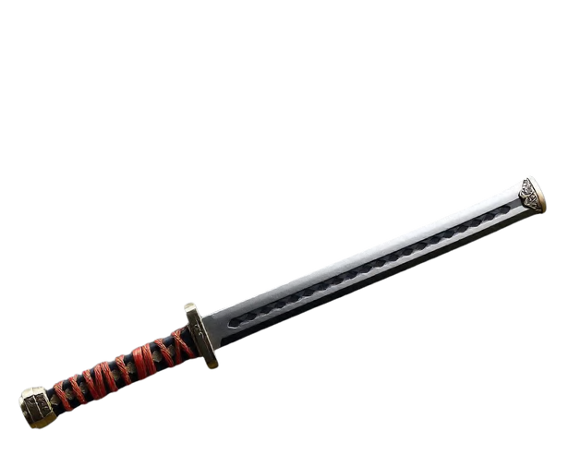

One of the key features of Cinderwake is the ability for players to craft and sell weapons. By gathering materials and resources found throughout the game world, players can craft their own weapons, customizing them to their liking. These crafted weapons can then be sold to other players, allowing for a dynamic player-driven economy.

# TOKENIZE YOUR CRAFTED ASSETS

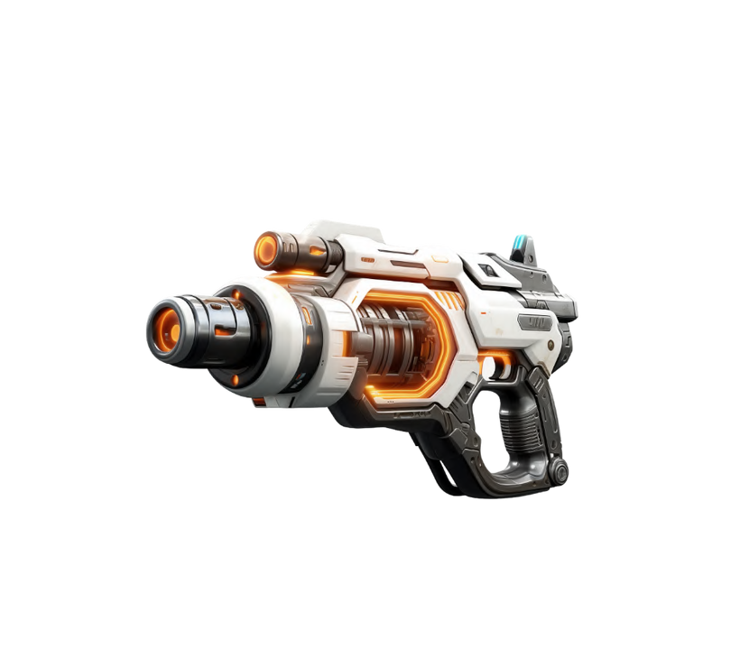In Cinderwake, players have the exciting opportunity to craft items, which hold unique attributes and capabilities. What sets these items apart is their potential to be turned into Non-Fungible Tokens (NFTs), a revolutionary concept in the world of gaming.

Through the process of tokenization, these crafted items are

transformed into digital assets with inherent value, secured on the Solana blockchain via Web3 technology.

Once converted into NFTs, these exotic items can be traded on NFT marketplaces, allowing players to buy, sell, and collect them like rare treasures. This introduces a whole new dimension of ownership and investment within the game, as players can now truly own their virtual possessions beyond the confines of the game world.

# WHAT ABOUT REVENUE?

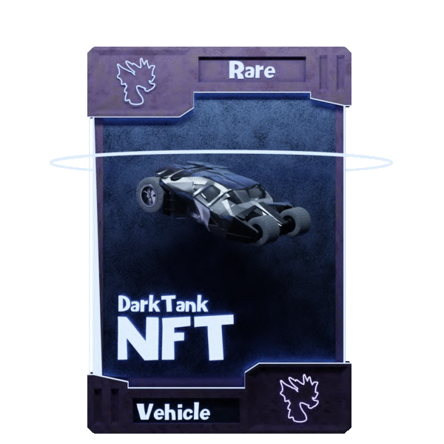

Cinderwake offers a range of revenue models to support its dynamic gaming universe. The main four expected revenue streams include:

* Battle Pass Sales
* In-app Purchases
* Advertising
* NFT Sales Commissions

These revenue streams ensure Cinderwake's sustainability while providing diverse options for player engagement and enjoyment.

# TOKENIZATION



**Crafting Blueprint**

The player crafts an NFT version of a vehicle which calls the contract to mint an NFT

**Smart Contract**

This process happens in the backend, the player does not have to bother with any complicated mechanics.

*True Ownership*



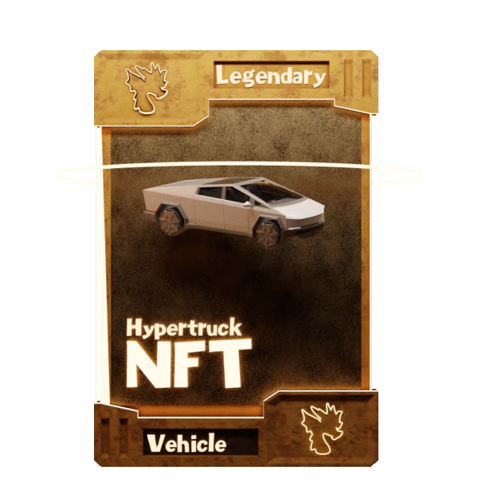

The player now owns a sellable NFT!

Creates a unique Token ID and charges the player the needed fees

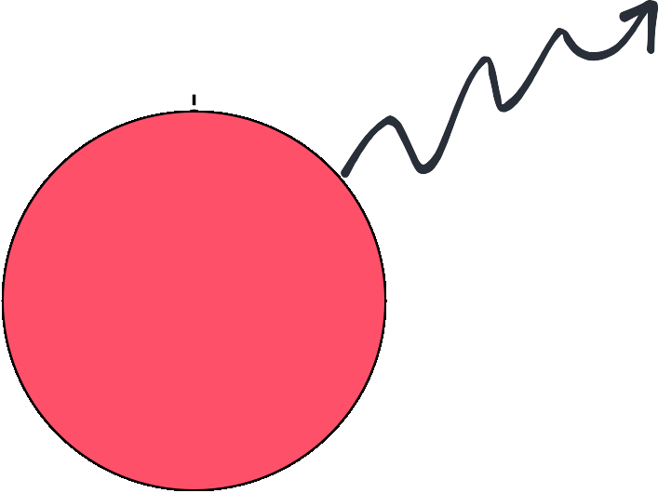

**Inventory has been updated**

The minted NFT get’s transferred into the players inventory (wallet)

**Unique Token ID (NFT)**

# BURN TO HATCH

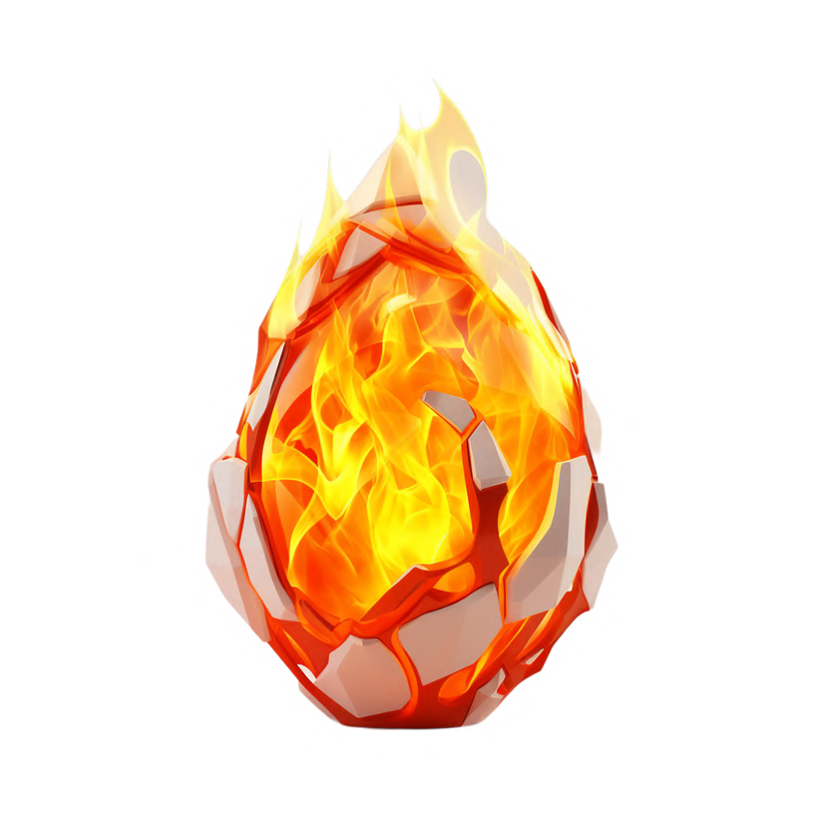Cinderwake"s innovative Web3 integration introduces a groundbreaking mechanism for supply reduction of its project token, $CINDER. When players opt to hatch eggs, a predetermined amount of $CINDER tokens are automatically burned, cleverly reducing the token"s circulating supply. This ingenious approach not only fosters scarcity but also drives up the token"s value by increasing its rarity.

Cinderwake’s mechanism uniquely combines gameplay with token economics, incentivizing players and benefiting the token ecosystem. This innovative approach enhances both gameplay and tokenomics, distinguishing Cinderwake in Web3 gaming..

# BURN MECHANISM

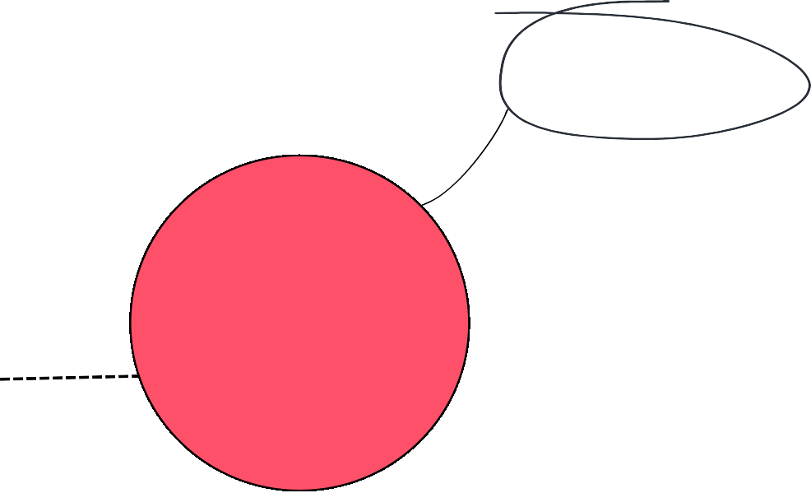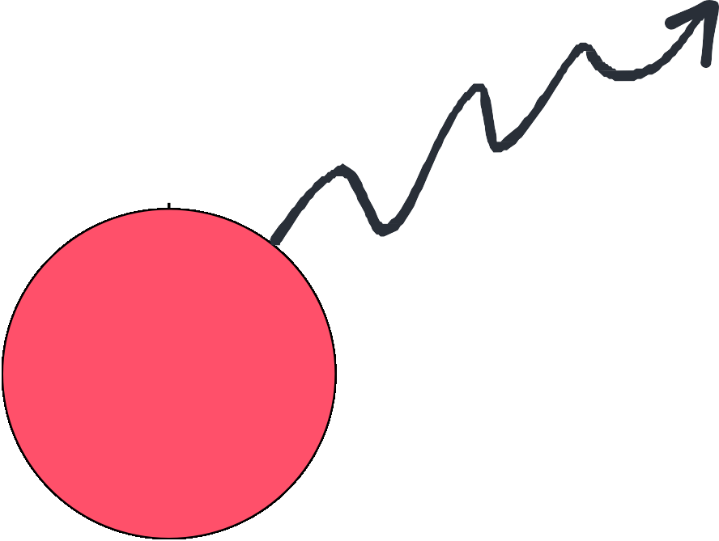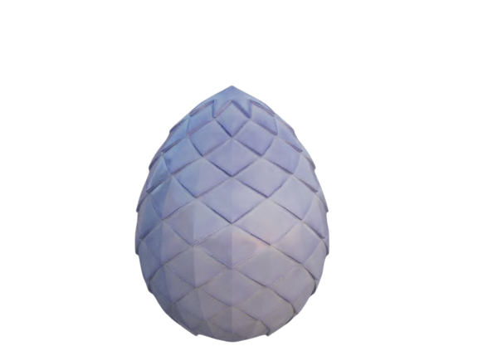

**Hatching an Egg**

Smartcontract Call to retrieve token balance from the player and charge the needed tokens

**Smart Contract**

This process happens in the backend, the player does not have to bother with any complicated mechanics.

*Let's do this!*

Eggs add the excitement of hatching unique dragons, with it’s unique burning mechanism it also positively effects the token economy.

The player has successfully hatched an egg

Confirmations happens on the blockchain. The user sees an animation of the egg rolling and shaking waiting to open.

Sends the retrieved tokens to the dead address

*0XDEAD*

**Egg Hatches**

Verification happens on the blockchain, if True = Egg hatches, if False = Player gets notified to have enough $CINDER

**Dead Address**

# CINDERWAKE TOKEN

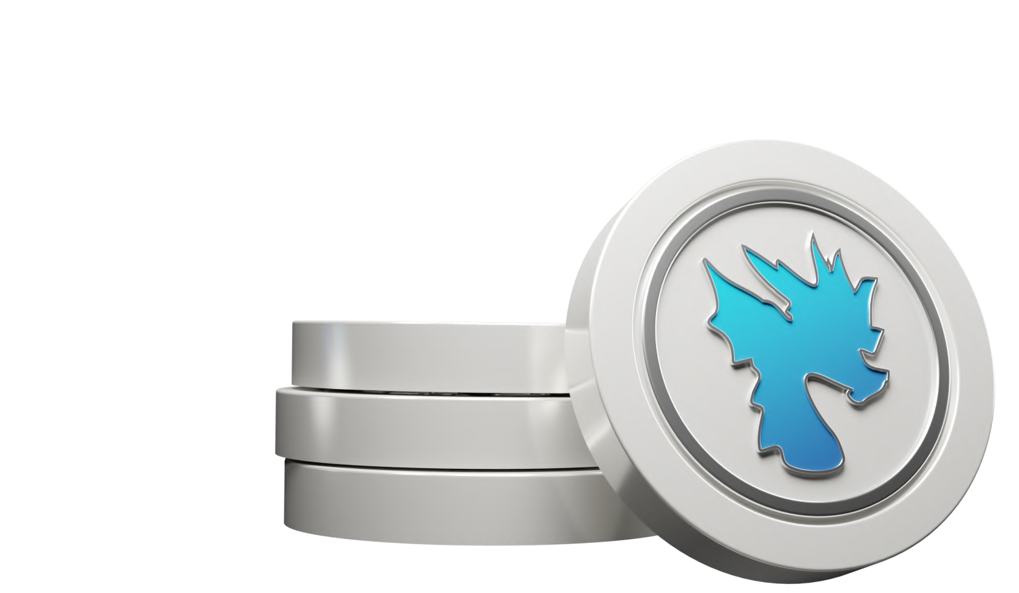

$ CINDER, the native crypto token of Cinderwake, is now available in its ICO state. As an early adopter, you have the exclusive opportunity to become a part of this groundbreaking project poised to revolutionize the gaming industry. With a robust ecosystem and promising tokenomics, $CINDER offers a chance to capitalize on the growing intersection of gaming and blockchain technology..

# $CINDER USECASE

The $CINDER token serves multiple key functions within the Cinderwake ecosystem:

1. **Egg hatching (Burning)**: Players can utilize $CINDER tokens to hatch eggs in the game, effectively burning the tokens as part of the hatching process.
2. **In-game currency**: $CINDER serves as the backup currency within the game for purchasing items, cosmetics, or upgrades.
3. 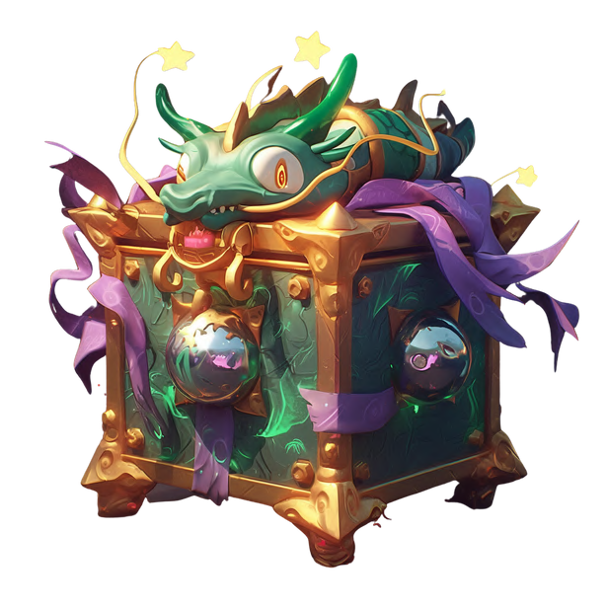**Staking for Gaming Rewards**: Players can stake $CINDER tokens to earn exclusive items and bonuses, encouraging them to hold and engage with the token, thus boosting participation in the Cinderwake gaming ecosystem.
4. **Gacha boxes**: Players are incentivized to use $CINDER tokens to perform certain actions faster within the game such as crafting/upgrading items and to open Cinderwake Gacha Boxes within the game.

# $EMBR PRE-SALE ROUNDS



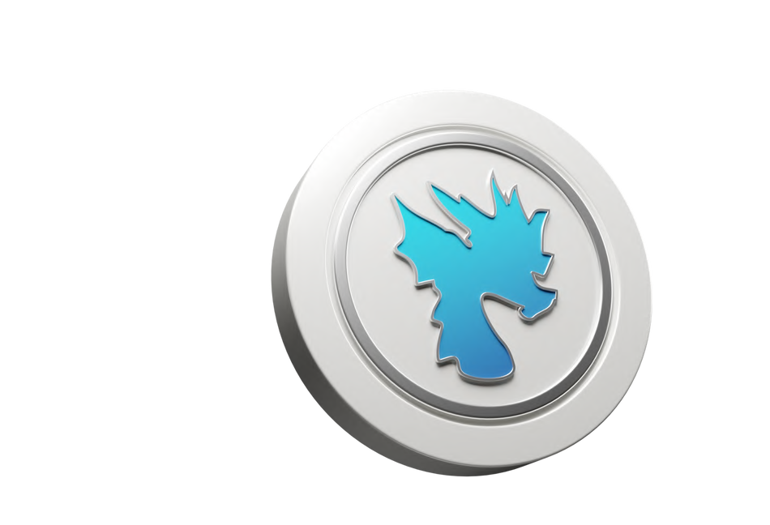Founder/Angel & Seed Rounds: **$0,025** per token. Raise: **$1.750.000**

Private Sale Round: **$0,030** per token. Raise: **$300.000**

Altura NFT Round: **$0,033** per token (NFT Based). Raise: **$225.000**

Public Presale/Launchpad Round: **$0,035** per token. Raise: **$750.000**

**Total Raise: $3.025.000**

# $CINDER PRE-SALE

The **$CINDER** token ICO price tiers:

Founder/Angel Round: **$0,025** per token. Seed Round: **$0,025** per token.

Private Presale: **$0,030** per token. Altura NFT Round: **$0,033** per token. Public Presale: **$0,035** per token.

Launch Price: **$0,040** per token.

Development & EcoSystem Growth 30%



Operational Cost and Reserves 50%

Interested individuals have the opportunity to participate at various stages, each offering distinct pricing advantages.

Liquidity & Market Making 20%

**Total Raise: $3.025.000**

**EXPECTED USE OF FUNDS**

# VESTING SCHEDULE

### TIER 1 - Angels & Founders

17,50% Unlock at TGE - 6 months Linear Vesting

### TIER 2 - Seed & Private Round

20,00% Unlock at TGE - 8 months Linear Vesting

### TIER 3 - Public Presale & Team

20,00% Unlock at TGE - 9 months Linear Vesting

### TIER 4 - Airdrop & Swap Recipients

20,00% Unlock at TGE - 12 months Linear Vesting

# TOKENOMICS

0,00% 5,00% 10,00%

Ecosystem Rewards (57,16m)

Seed Round (50m)

14,29%

12,50%

Marketing (42,84m) CEX listings (32,93m)

Airdrop Competitions (28,56m) Team Tokens (28,56m) Reserves (28,56m) Initial Liquidity (21,42m)

Public Presale Round (21,42m) Angel/Founders (20m) Market Making (16m)

Airdrop to $DEXIO Holders (14,28m) Airdrop to ICO Partners (14.28m) Private Presale Round (10m)

5,33%

5,33%

5,00%

4,00%

3,57%

3,57%

2,50%

7,14%

7,14%

7,14%

8,93%

10,71%

$DEXIO Presale Swap (7,16m) Altura NFT Presale (6,83m)

1,79%

1,70%

Percentage

Initial Circulating Supply (60,89m) - **15,22%**

Initial Market Cap - **$2.435.600**

Initial Liquidity - **$1.715.200**

Initial Vested Supply (133,06m) - **33,27%**

Initial Token Locks (206,05m) - **51,51%**

Total/Max Supply (400m) - **100%**

# INDUSTRY VALUATION

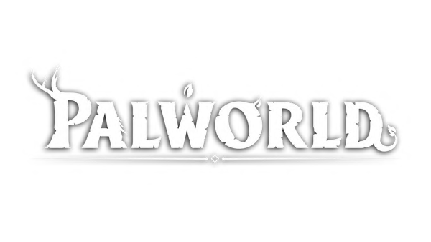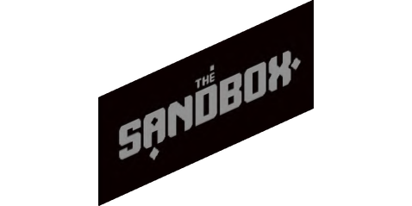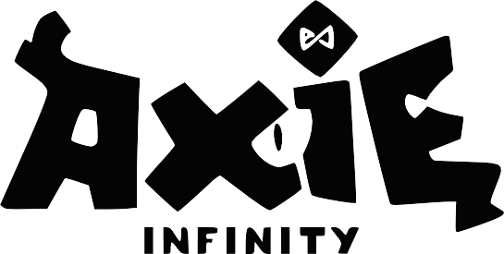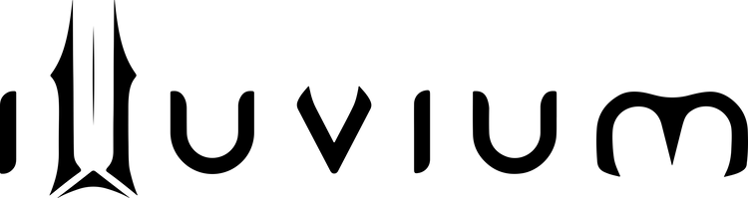

## WEB2

**2023 Valuation: 187BN**

**187 Billion has been generated by videogames in 2023.**

## WEB3

**Cinderwake revolutionizes gaming with blockchain, NFTs, and mobile compatibility, providing true asset ownership and dynamic gameplay. Say goodbye to boring idle and auto-battling open-world games!**

## WEB3

**2023 Valuation: 2.3BN WEB3 games are gaining**

**traction, immense growth left.**

# GO TO MARKET STRATEGY

**Media & Press Releases:** Consistently updated press releases with a wide range of media partners including IBC Group, Yahoo News, Bloomberg News and more will bring attention to Cinderwake, attracting new partnerships and players.



**Influencers & KOLS:** With over 3 years of experience interacting with Web3 influencers and KOLs, Cinderwake is partnering with some of the most trusted names in the space to promote the project and the game. An ambassador program is being developed to ensure long term partners and ongoing credibility within the space.

**Social Media Campaigns & Community development:** Everyone knows that the best marketing is done by groundswell where real people all over the world promote your product. Airdrop competitions, social media campaigns, and community building activities are all planned with the most effective strategies employed.

**Partnerships:** Partnering with Web3 builders on the cutting edge of the space is key to exponential growth. Cross-marketing campaigns, asset integrations, and joint releases with some of the biggest names in Web3 gaming are all being planned.

# DON’T MISS OUT ON THIS ADVENTURE!

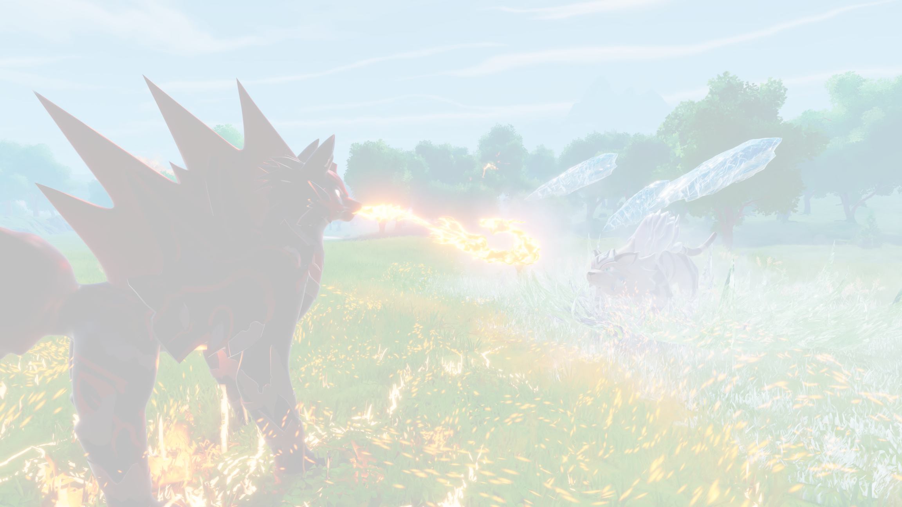

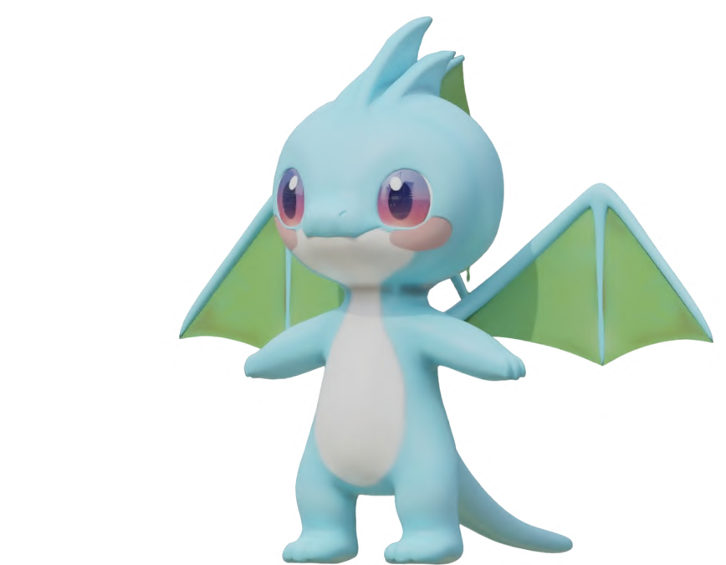**THANK YOU!**

**If we’ve sparked your interest you can contact us at:** [**contact@cinderwake.io**](mailto:Support@cinderwake.io)